Sprint 3 Planning

Overall

* Sprint ends Nov 17th
* We will work on it for 24 hours
* Evaluate current progress towards app completion and future tasks needed
* Scrum Master: Jackson

Stories

1. (M) Add ‘home’ pages for each user type

• This will be shown after a user logs in, it will be their ‘central control’. Like for a manager it will be a page to navigate to the functions of a manager.

• For a barista this will simply be a place to see all of the undelivered drinks.

• etc.

1. (S) Proper redirects on user login
   * This should be pretty simple.
   * Just ensure each user time goes to the proper place upon login
   * We had some issues with this last sprint so it should be fixed this sprint
2. (L) Ensure a game can be played from start to finish
   * Sponsor should initiate a game
   * Player should be added to a game by sponsor
   * Player plays through all of the holes and is shown a leaderboard
3. (M) Ordering Drinks functionality
   * Players can order drinks as they play
   * Baristas can see orders and fulfill them
4. (S) Make the app a little more ‘pretty’
   * Just some basic clean styling is alright
5. (M) Kinda Finalize Unit Tests
   * Unit tests should be at 70-100% coverage by the end of the sprint
6. (L) Database population upon initialization.
   * When the site is first setup there should be an initial db population file which will make sure certain necessary info is present in the db for the app to run properly

Story items after planning

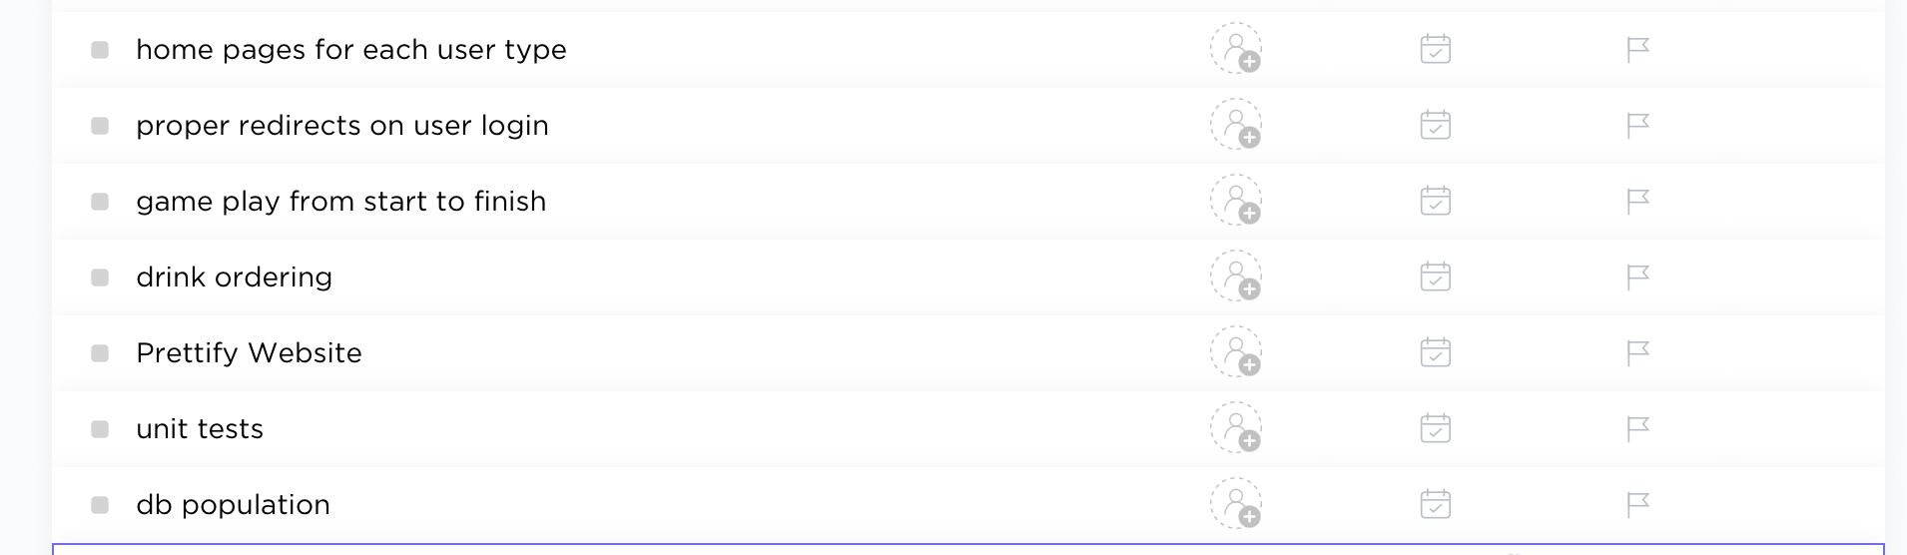

Burndown Chart of Story points (optimal)

